INFORMATICS PRACTICES (Code 065)-2012-13
CLASS :- XII
(MOCK TEST)

Note: 1. All questions are compulsory.
2. Attempt the question paper section wise.
3. All Questions carry equal marks.

SECTION A
Q1. Answer the following questions:
Dream Land Enterprises has computerized its billing. The following data entry screen is used to generate bill. 6
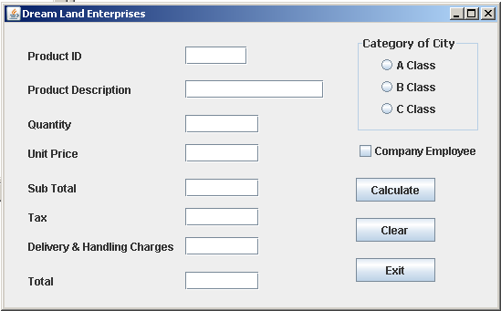

The criteria for calculation of delivery and handling charges is as given below-
Category of City | Charges
A Class | Rs. 3500
B Class | Rs. 4000
C Class | Rs. 4500

- Write the code to make the text fileds txtSubTotal, txtTax, txtDelHanCh and txtTotal non editable and set the category of city as C class.
- Write code to do the following-
- Write the code for Calculate button to calculate and display Sub Total, Tax, Delivery & Handling Charges and Total depending on the category of the city.
  - Sub Total is calculated as Unit Price * Quantity.
  - Tax is calculated as 7.85% of Sub Total
  - Total is calculates as the sum of Sub Total, Tax and Delivery and Handling Charges. If Company Employee check box is checked then tax should be 2.5%.
- When Clear button is clicked all the text boxes should be clear and Close the application when Exit button is pressed.
- Write a java method to display the name of week days? 2
- Differentiate call by value and call by reference 2
- Write a java code to obtain list of selected items from a list namely NameList 2

Q2. Answer the following question:-

i) | Differentiate between a Text Field, Text Area and password field. | 2
ii) | What is the difference between if and switch statements? | 2
iii)  iv)  v) | What are the operators supported by Java explain logical operators?  Given the following expression:-  a ) res= 30; b ) res==30;  - What is the difference between these two statements?  - What will be the value of res if initial value of res is equal to 48  Write a java code for the Item event handler of a checkbox(namely incCB) that increments a variable total and display it on a label(namely count) the checkbox is selected. | 1  2  2
vi) | How private members different from public and private members of a class? | 1

Q3. Answer the following questions.
a) State the output of the following code: 1
int a = 10 , b = 5 ;
if ( a > b ) {
if ( b > 5 )
tf1. setText ( " b is " + b ) ;
}
else
tf1. setText ( "a is " + a ) ;
b) What will be the output of the following code fragment when the value of ch is ‘B’. 1
switch (ch) {
case ‘A’ : ta1. append (" Grade A " );
case ‘B’ : ta1. append (" Grade B " );
case ‘C’ : ta1. append (" Grade C " );
case ‘D’ : ta1. append (" Grade D " );
break ;
default : ta1. append (" Grade F " );
}
- Rewrite the following code using do-while loop. 2
for ( i = 0 ; i < 10 ; i ++ )
ta1. append ( 2 + " x " + i + " = " + ( 2 * i ) ) ;
d) Rewrite the following program code using a switch statement : 2
if ( code = = 1 )
Month = "January" ;
else if ( code = = 4 )
Month = "April" ;
else if ( code = = 8 )
Month = "August" ;
else
Month = "No Match" ;
e) The following code has error(s). Rewrite the correct code underlining all the corrections made: 2
int Sum = 0 , Step = 5 ;
int I ;
for ( i = 0 ; i < = 5 , i ++) ;
{
Step += 5 ,
Sum += Step ;
}
jTextArea1 . showText ( " " + Sum )

- Find error :- 1
if (sex==1)
jLabel1.setText(“Male”);
else ;
jLabel1.setText(“Female”)
- What will be the value of x and y after execution of following code : 1
int x , y = 0 ;
for ( x = 1 ; x < = 5 ; ++x )
y = x + + ;
- - y ;
Section B
Q4. Answer the following questions.

- Create a table customer based on the following chart:- 1
Field Name | Type | Constraint
Cust_no | Int(2) | PRIMARY KEY
D_name | Varchar(15)
Cust_name | Varchar(30) | NOT NULL
Purchase_date | Date
amount | Double(6,2)

- Create a query to add the following data in the above table:- 1
3, Food, Gautam Mishra, 3rd may 2011, 12875.25
- Write a query to display records whose Cust_name start from letter ‘a’ and sorted alphabetically order of d_name.(Customer table) 1
- Display those record whose amount greater than 12000 and Purchase_date more than ‘1999-01-12’ 1
- Add one more column in above table(Address varchar(30)) 1

- Drop one column amount from above table 1
. g) Write output of the following:- 4
- Select UPPER(‘COMPUETR’);
- Select SQRT(81);
- Select MOD(39,3);
- Select POWER(3,5)
- Select Trim(“ CANBERA “);
- Select Length(“16 A EX-ARERA”);
- Select SUBSTR(“EXTENTION”,5,3);
- Select ROUND(5699.196,-1);

Q5. Answer the following questions.

- Name the SQL commands for the following:- 1
- To MODIFY ROW in a table.
- To view structure of the table
- Name the keyword used to avoid duplicate rows in a query. 1
- Explain the need of GROUP BY clause in SELECT query with example.

- Define a tuple, attribute, degree and cardinality. 2

- Write a join query based on two table employee, dept where deptno is common column between two tables 1

- Write the attributes of <table> tag? 1

- Write a query to add constraint like Primary key in table student with rollno field 1

- What is primitive data types in MYSQL? 1

- What is primary key? How is it different from candidate key? Explain with the help of suitable example. 2
- What is function overloading in java? 1

